Friends of
Meadow Farm

Yard Sale
May 18, 2019
8 a.m.-1:00 p.m.
Glen Allen Market
3007 Mountain Rd. Glen Allen, VA

To benefit the Kitchen Fund

An exterior kitchen will enhance the foodways program at Meadow Farm

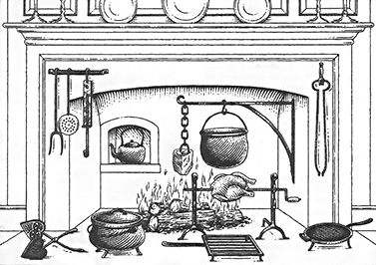

One Man’s Discards—Another Man’s Treasures

For more information: eikmeier49@hotmail.com

Friends of Meadow Farm
Yard Sale

May 18, 2019--8 a.m.-1:00 p.m.
Glen Allen Market
3007 Mountain Rd. Glen Allen, VA
To benefit the Kitchen Fund

Reserve your
10’ x 10’ space now!
Deadline: May 11, 2019

Check out
Friends of Meadow Farm &
Henrico Historical Society
on Facebook

Check one

- $25.00 per space—
All money collected is yours to keep
How many spaces?______
All remaining items must be removed at the end of the day
- - - - - - - - - - - - - - - - - -
- No fee per space—All donations & money collected is donated to the Friends of Meadow Farm Kitchen Fund

Name
Address

Email
Phone

Make out check to:
Friends of Meadow Farm—Kitchen Fund
Send checks & registration to:
P.O. Box 1553
Glen Allen, VA, 23060

--OR—

Pay Online with Credit Card or Pay Pal: (includes transaction fee)
henricohistoricalsociety.org/shopping.html

